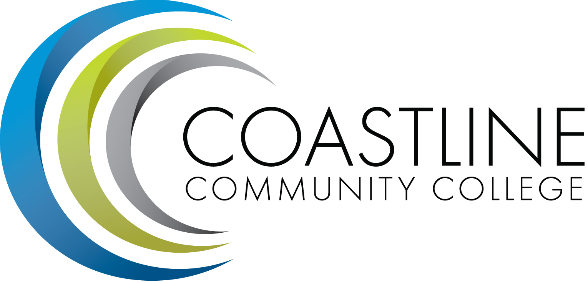
Planning, Institutional Effectiveness, and Accreditation Committee (PIEAC)
March 15, 2017
1:30 p.m. to 3:30 p.m.
Fourth Floor Conference Room

- CALL TO ORDER
  - Roll Call
  - Welcome
  - Adoption of Agenda
  - Approval of Minutes: March 1, 2017

- REPORTS

- DISCUSSION
3.1 Initiative and Resource Prioritization V. Rodriguez, C. Nguyen, R. Miyashiro, A. Zentner

4. STANDING REPORTS
4.1 Accreditation V. Rodriguez
4.2 Budget Committee R. Lockwood
4.3 Program Review A. Zentner
4.4 Grants D. Aistrich
4.5 President’s Report L. Adrian
4.6 Wing Reports V. Rodriguez, C. Nguyen, R. Miyashiro
4.7 College Council V. Rodriguez
4.8 Facilities C. Nguyen
4.9 MECTBD J. Groot
4.10 Student Success Committee B. Keeler
4.11 Institutional Effectiveness Grant A. Zentner
4.12 College Promise L. Adrian
4.13 Other Committees Committee

4. ANNOUNCEMENTS (1-2 minutes per)

5. ADJOURNMENT

